
Manufacturing Downtime Analysis
Soda Bottling Production Line


By: MOED BARTELS

Executive Summary
Tools: Excel | Power Query | Power BI
This analysis examines productivity and downtime across a soda bottling production line, focusing on line efficiency, major downtime drivers, product-level downtime patterns, and operator performance.
Across 38 production batches, the line recorded 3,858 minutes (64.3 hours) of production time and 1,388 minutes (23.1 hours) of downtime. The resulting line efficiency was 64.02%, while average downtime was 36.53 minutes per batch.
Downtime was concentrated among a small number of factors. Machine adjustment, machine failure and inventory shortage were the three largest sources of recorded downtime, together accounting for 811 minutes (58.4%) of total downtime.
Downtime also varied by product, with Cola recording the highest total downtime at 771 minutes (12.9 hours).
Operator efficiency was relatively closely grouped across the four operators. A separate analysis of downtime factors classified as Operator Error was also conducted to identify patterns in operator-error-classified downtime without implying individual responsibility for those events.
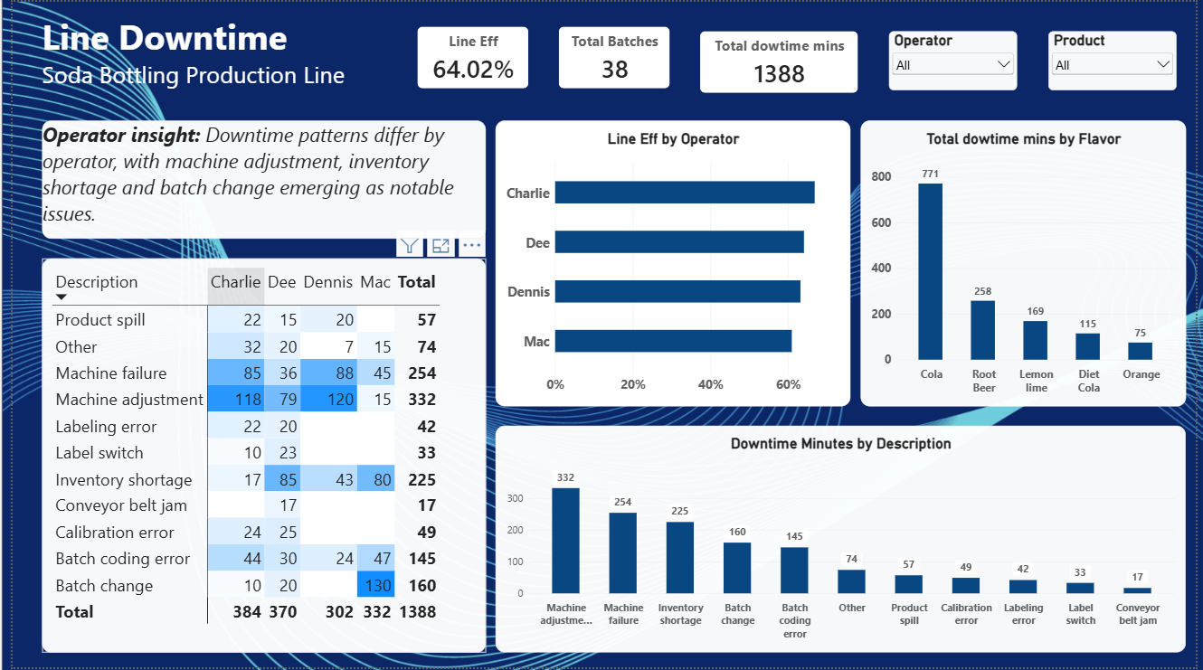

2. Production Performance
The production line recorded 38 batches during the period analyzed.
Total production time was 3,858 minutes (64.3 hours), while total recorded downtime was 1,388 minutes (23.1 hours). This resulted in an average downtime of 36.53 minutes per batch.
The overall line efficiency was 64.02%, providing a baseline measure of production performance for the period analyzed.
Performance Summary
Metric | Result
Line Efficiency | 64.02%
Total Batches | 38
Total Production Time | 3,858 mins / 64.3 hrs
Total Downtime | 1,388 mins / 23.1 hrs
Average Downtime per Batch | 36.53 mins

3. Leading Downtime Drivers
Downtime was concentrated among several key factors.
The three largest sources of downtime were:
- Machine adjustment — 332 minutes
- Machine failure — 254 minutes
- Inventory shortage — 225 minutes
Together, these factors accounted for 811 minutes, representing approximately 58.4% of total recorded downtime.
Machine adjustment was the largest individual downtime factor, followed by machine failure and inventory shortage.
These categories provide useful starting points for further operational investigation. However, the dataset identifies the downtime factor and duration rather than establishing the underlying root cause of each event.
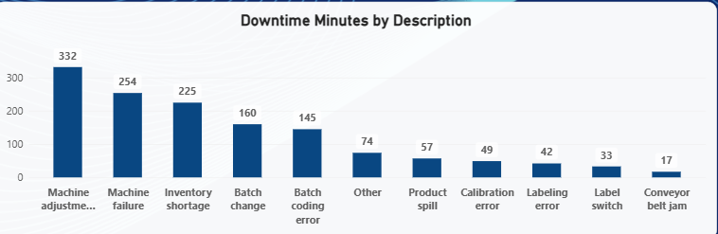

4. Downtime by Flavor
Downtime varied considerably across the different flavors produced.
Flavor | Downtime | Equivalent Hours
Cola | 771 mins | 12.9 hrs
Root Beer | 258 mins | 4.3 hrs
Lemon Lime | 169 mins | 2.8 hrs
Diet Cola | 115 mins | 1.9 hrs
Orange | 75 mins | 1.3 hrs
Cola recorded the highest total downtime at 771 minutes (12.9 hours), considerably higher than the other flavors.
However, total downtime alone does not establish that Cola itself causes more downtime. Differences in production volume, number of batches, product changeovers and other operating conditions may contribute to the observed pattern.
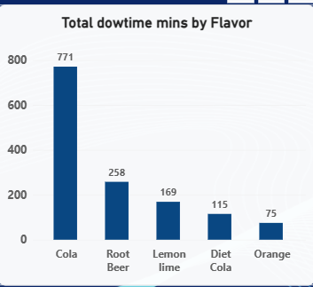

5. Operator Performance
Operator efficiency was relatively closely grouped across the four operators.
Charlie recorded the highest efficiency, while Mac recorded the lowest. However, the differences between operators were relatively small.
This suggests that overall efficiency was broadly similar across the operators during the period analyzed. For additional context, the analysis also examined the types of downtime recorded for each operator.
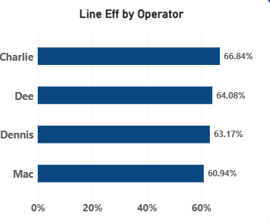

6. Operator Downtime Patterns
The unfiltered operator analysis examines all downtime recorded for each operator, regardless of how the downtime factor was classified.
The results show that the distribution of downtime factors differed between operators.
For example, machine adjustment was particularly prominent for Charlie and Dennis, while batch change was especially prominent for Mac.
This view is useful for understanding the overall downtime patterns associated with each operator, but it should not be interpreted as evidence that an operator caused a particular downtime event.
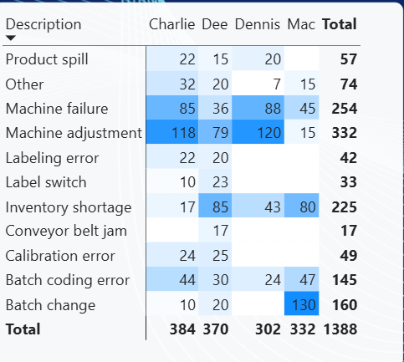

7. Operator-Error-Classified Downtime
To answer the question of whether operators struggle with particular types of operator error, the analysis was narrowed to only downtime factors classified as Operator Error = Yes in the dataset's data dictionary.
Across these factors, there were 776 minutes (12.9 hours) of downtime classified as operator error.
The largest operator-error-classified factors were:
- Machine adjustment — 332 minutes
- Batch change — 160 minutes
- Batch coding error — 145 minutes
The pattern varied by operator:
- Charlie: Machine adjustment — 118 minutes
- Dee: Machine adjustment — 79 minutes
- Dennis: Machine adjustment — 120 minutes
- Mac: Batch change — 130 minutes
This indicates that the dominant operator-error-classified downtime factor was not identical across all operators.
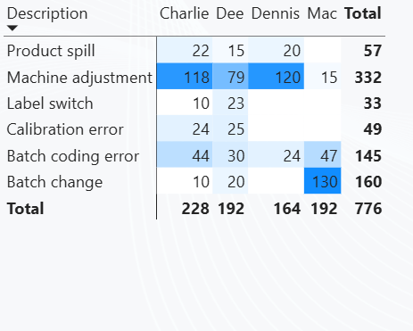
Important Data Dictionary Note
The Operator Error classification applies to the downtime factor, not to the individual operator.
A factor classified as "Yes" means that the dataset categorizes that type of downtime as an operator error. It does not establish that a particular operator was personally responsible for causing the event.
For example, Machine adjustment, Batch change, Product spill, Batch coding error, Calibration error and Label switch are classified as operator errors in the dataset.

8. Comparing Overall Downtime and Operator-Error Downtime
Two views were used to provide a clearer picture of operator-related downtime.
The unfiltered matrix shows all downtime recorded across operators, including factors such as machine failure and inventory shortage.
The filtered matrix shows only factors classified as operator errors in the dataset.
This distinction is important because a downtime factor can contribute to an operator's overall downtime without being classified as an operator error.
For example:
- Inventory shortage is classified as not an operator error.
- Machine failure is classified as not an operator error.
- Other is classified as not an operator error.
- Label switch is classified as an operator error.
Therefore, the 1,388 minutes of total downtime and the 776 minutes of operator-error-classified downtime represent two different measures.

9. Key Insights
Line Efficiency
The production line recorded an overall efficiency of 64.02% across 38 production batches.
Downtime
The line recorded 1,388 minutes (23.1 hours) of downtime, with an average of 36.53 minutes per batch.
Major Downtime Drivers
Machine adjustment, machine failure and inventory shortage accounted for 811 minutes, or approximately 58.4% of total downtime.
Product-Level Pattern
Cola recorded the highest total downtime at 771 minutes (12.9 hours).
Operator Performance
Operator efficiency was relatively closely grouped, with Charlie recording the highest efficiency and Mac the lowest.
Operator-Error Patterns
Among downtime factors classified as operator errors, machine adjustment was the largest category overall. However, the dominant factor varied by operator, with batch change particularly prominent for Mac.

10. Recommendations
Based on the analysis, the following actions could help reduce downtime and improve line efficiency:
- Prioritize machine adjustments and machine failures.
Machine adjustment (332 minutes) and machine failure (254 minutes) were two of the largest downtime factors. Reviewing the causes of these events and strengthening preventive maintenance and machine setup procedures could help reduce recurring downtime.
- Investigate inventory shortages.
Inventory shortages accounted for 225 minutes of downtime. Reviewing material availability, replenishment processes and production planning could help prevent avoidable stoppages.
- Target operator-related downtime by factor.
Rather than treating operator error as an indication of individual performance, focus on the specific downtime factors classified as operator error. Machine adjustment was particularly prominent, while individual operators also showed different patterns in their downtime factors. This could support more targeted training or process improvements.
- Investigate Cola production downtime.
Cola recorded the highest total downtime at 771 minutes. Further investigation into whether this is related to production volume, product changeovers, machine settings or other process factors would help determine whether corrective action is needed.
- Monitor operator efficiency alongside downtime patterns.
Operator efficiency was relatively closely grouped, so differences should be investigated alongside the types of downtime experienced rather than using efficiency alone to identify underperformance.

11. Areas for Further Investigation
The findings provide several areas for deeper analysis.
Machine Adjustment
Machine adjustment was the largest downtime factor at 332 minutes. Further analysis could examine whether these events are concentrated around particular products, operators or production stages.
Machine Failure
Machine failure accounted for 254 minutes of downtime. Reviewing the individual events could help identify recurring equipment or maintenance issues.
Inventory Shortage
Inventory shortage accounted for 225 minutes. Further analysis could investigate whether shortages are concentrated around particular products or production periods.
Operator-Error-Classified Downtime
Further analysis could examine whether particular operator-error-classified factors are associated with specific products, shifts or production conditions.
Performance Tracking
Repeating the same analysis over future production periods would allow the business to monitor whether line efficiency improves and whether downtime decreases.

12. Limitations
This analysis describes patterns within the supplied production and downtime data and does not establish causality.
The Operator Error field is a classification assigned to downtime factors in the dataset. A factor marked "Yes" indicates that the dataset classifies that factor as an operator error; it does not establish that a specific operator was personally responsible for causing an event.
The dataset classifies the following factors as operator errors:
- Batch change
- Product spill
- Machine adjustment
- Batch coding error
- Calibration error
- Label switch
Factors such as Inventory shortage, Machine failure, Conveyor belt jam, Labeling error and Other are not classified as operator errors.
Total downtime by flavor also does not account for differences in production volume. A flavor produced more frequently may naturally accumulate more total downtime.
Finally, the dataset does not contain financial information about downtime, so the financial cost of the recorded downtime cannot be quantified from this analysis.

13. Conclusion
Across 38 production batches, the soda bottling production line recorded 3,858 minutes (64.3 hours) of production time and 1,388 minutes (23.1 hours) of downtime, resulting in an overall line efficiency of 64.02%. Average downtime was 36.53 minutes per batch.
Downtime was concentrated in three major categories: machine adjustment, machine failure and inventory shortage, which together accounted for approximately 58.4% of total recorded downtime.
Cola recorded the highest total downtime among the flavors analyzed, while overall operator efficiency remained relatively close across the four operators.
The operator analysis showed that downtime patterns varied between operators. When the dataset's Operator Error classification was applied, machine adjustment was the largest operator-error-classified factor overall. Charlie and Dennis recorded the highest machine-adjustment downtime among the operators, while batch change was particularly prominent for Mac.
Overall, the analysis provides a baseline view of production efficiency and downtime within the bottling line. The findings highlight several areas — particularly machine adjustment, machine failure and inventory shortage — that could be investigated further to identify opportunities for reducing downtime and improving production performance.

